HOW TO ORDER MARKETING MATERIALS
1. Log in to the site: https://gale.motownpress.com/
The Username will be your email address
The Password will be: cengage123

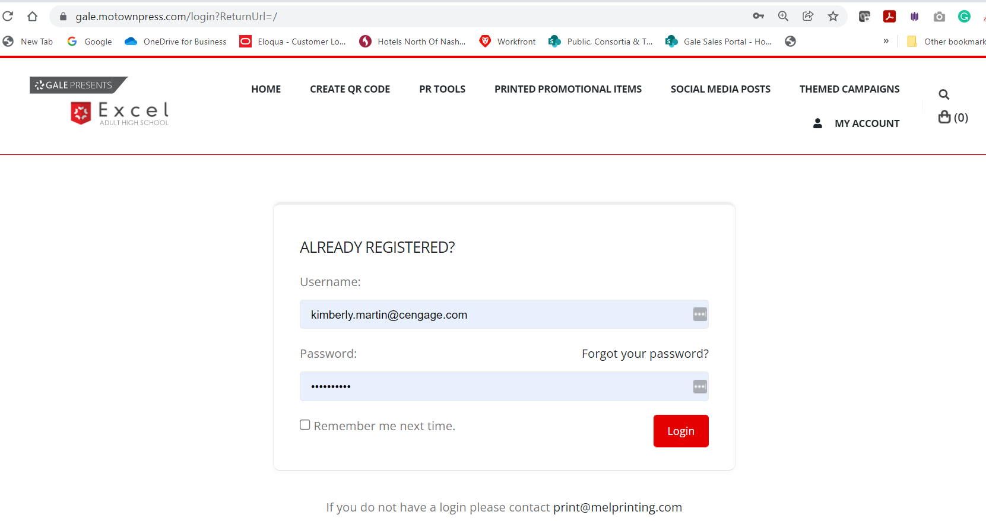

2. Create your QR code using the URL of your Excel Adult High School student requirement site. Once loaded, right-click on the QR Code and “Save Image As” to your download files.
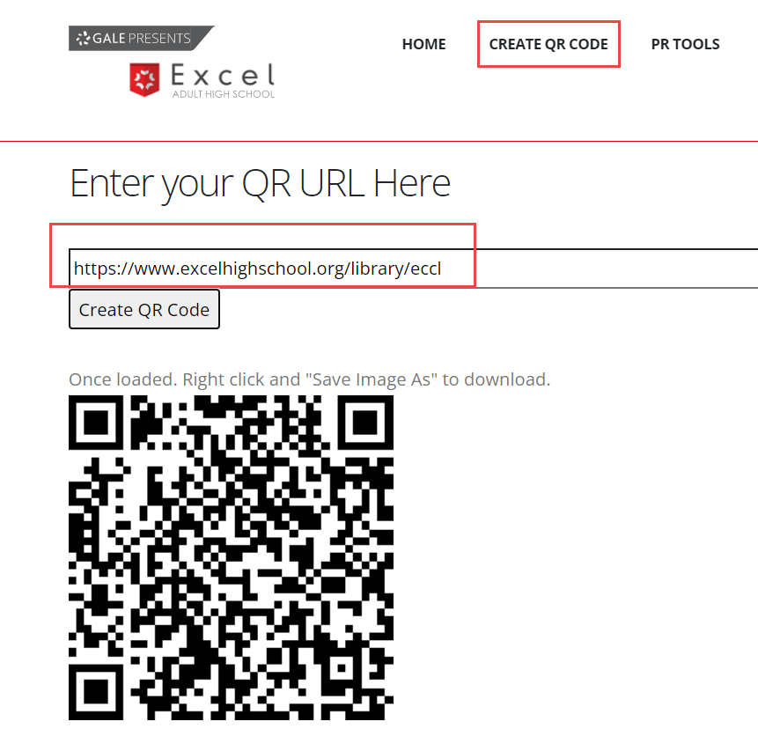

3. Click on the “Home” button to see the “Products” you can select from. If you are not participating in a State Library implementation of the Excel Adult High School Program, then select “Public Library Items.”
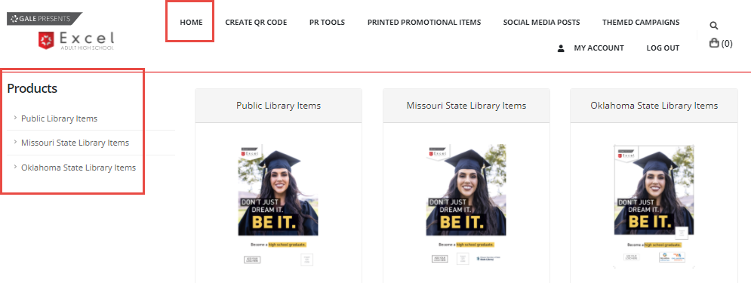

4. Select the item you would like to order by clicking on the “Order” button. You will be able to come back and order the other types of materials. 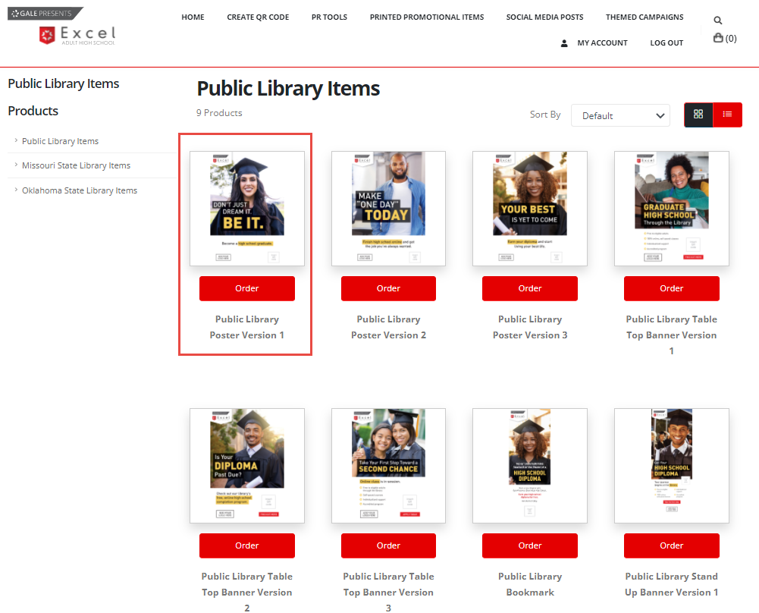

5. Upload your QR Code from your Downloads file by clicking the “UPLOAD” button on the far left side. When it has loaded, first click on the “Insert QR code” box on the marketing item image. Then click on the recently uploaded QR code on the left side of the page. When the QR code appears in the box on the marketing item, click on the checkmark “.”
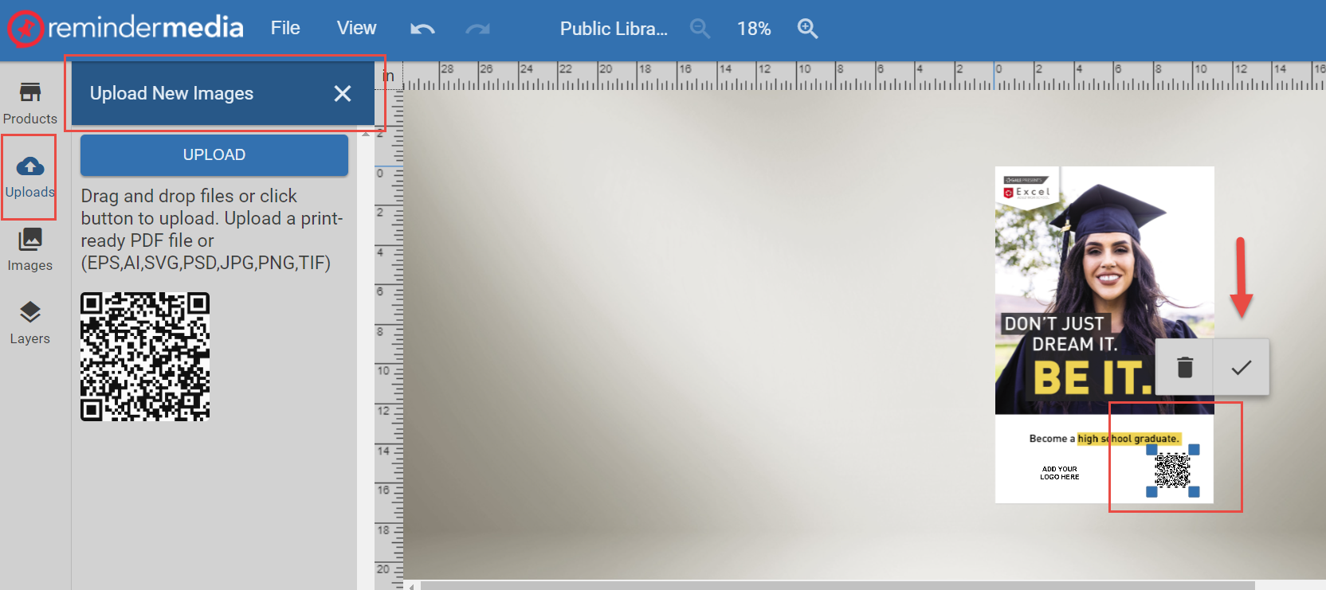

6. To upload your library logo, follow the same steps. Upload your logo by clicking on the “UPLOAD” button on the far left. Once there, click the “ADD YOUR LOGO HERE” box on the marketing piece. Then click on your logo and it will load on the marketing piece. Lastly, click the checkmark “.”

7. Next, click the “REVIEW & BUY” button in the upper right corner.
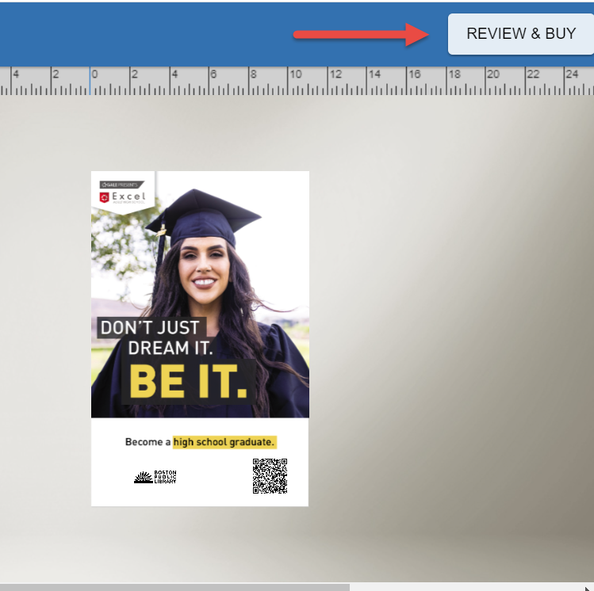

8. If it looks good, then click the “PURCHASE” button in the upper right corner.
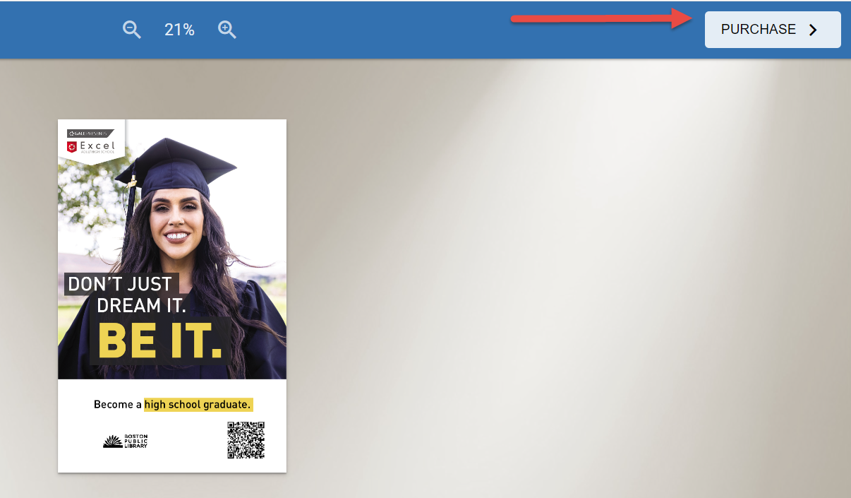

9. It will then load a page where you can download a low res image proof for review by you or other library staff. If you see an error and need to make an edit, you can click the “Edit” button and go back to make changes. When you are satisfied, you must check the box that you’ve read and reviewed the proof. Scroll down and advance by clicking on the “Next” button.
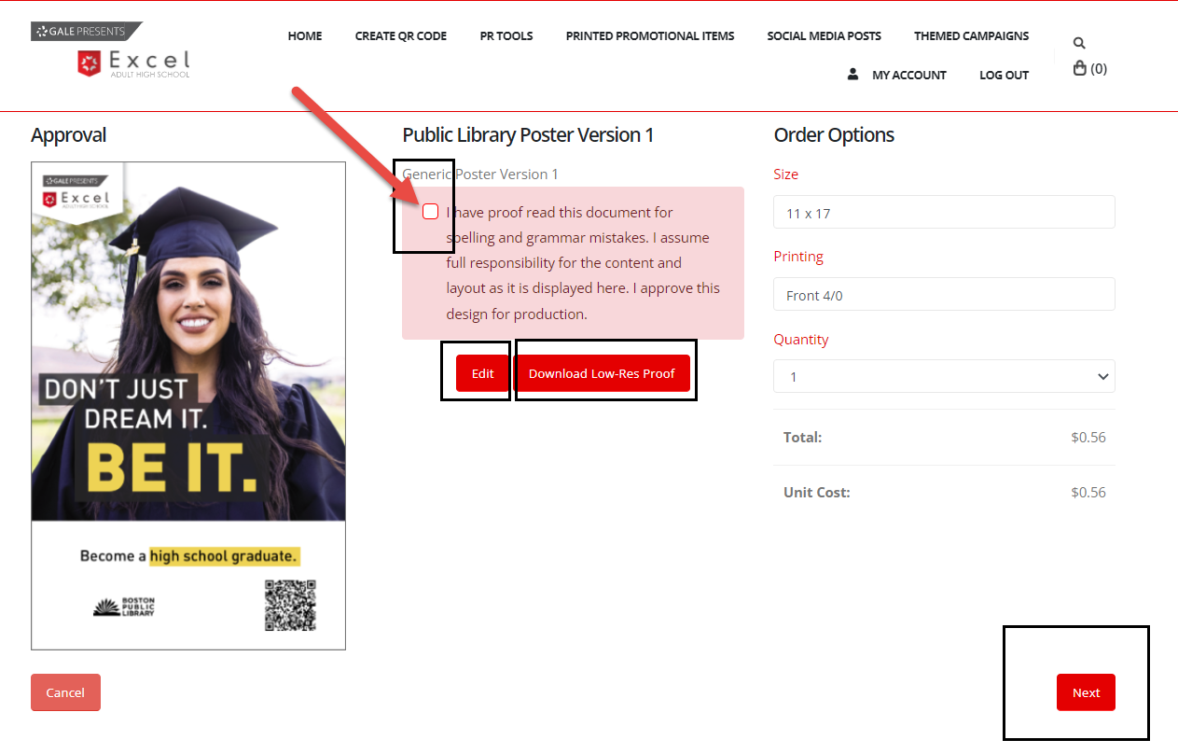

10. Here, you will select the number of items you are ordering. You will see the cost per unit and total cost. You will not be charged. You should have discussed with Gale your marketing budget and the quantities your library is ordering. If you are not sure of this number, please contact Gale before ordering.
When you are ready to place your order, click the “Proceed to checkout” button. If you have additional items to order, click the “Continue Shopping” button.
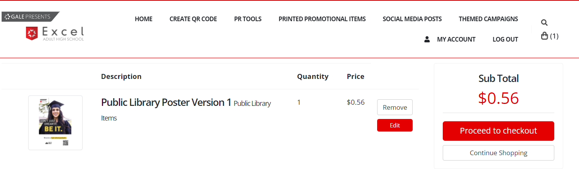
11. PLEASE NOTE the Bookmark has two sides to be customized. Be sure to add your QR code to Page 1 and your logo, and email and phone number to Page 2. Remember to review both pages too. Follow steps 7 – 10.
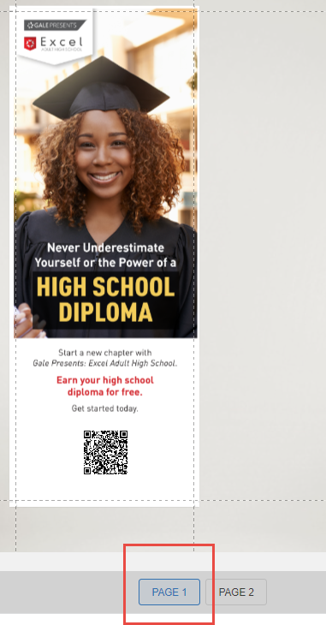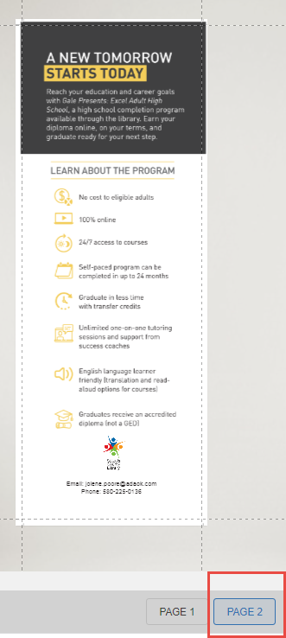

12. When you are ready to place your order, click the “Proceed to checkout” button. If you have additional items to order, click the “Continue Shopping” button.
If you click the “Proceeding to checkout” button, you will be taken to the “My Approvals” page. By doing this, Gale will be alerted that we need to review and approve your order. Notice the “Order” button is not clickable at this time.

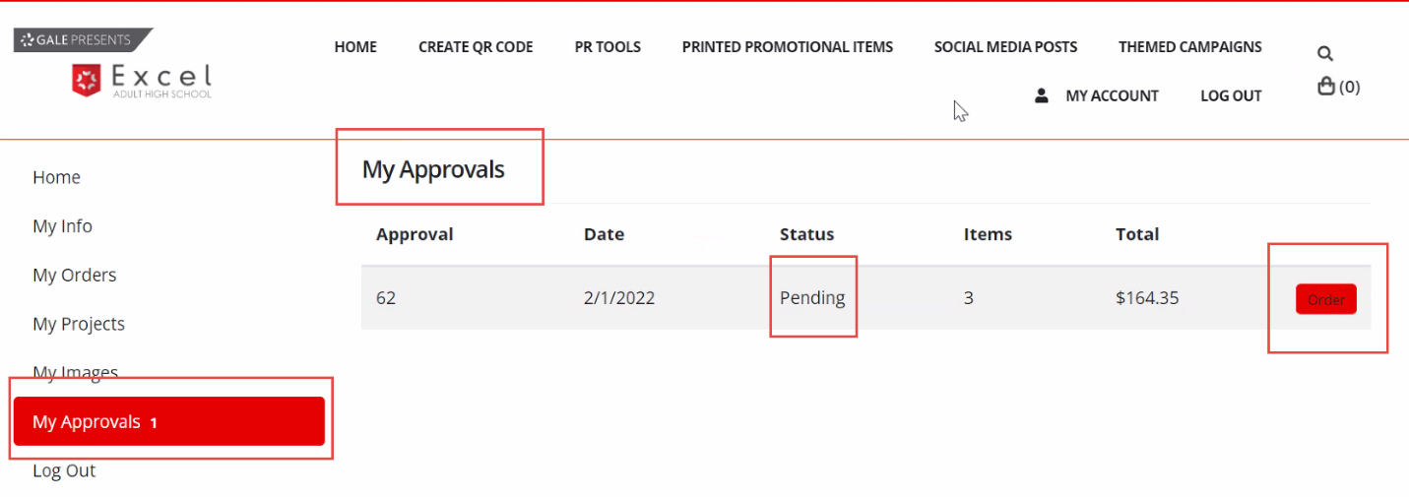

13. Gale will review and approve your order within a 24 hr period or sooner. You will receive an email when your order has been “Approved!” To complete your order, click on the link in the email or return to the “my-orders” page in your account. Click the “Order” button.
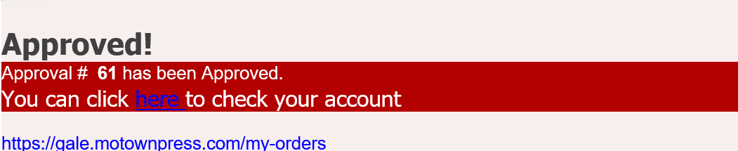

14. Next, add your shipping and billing information.
. 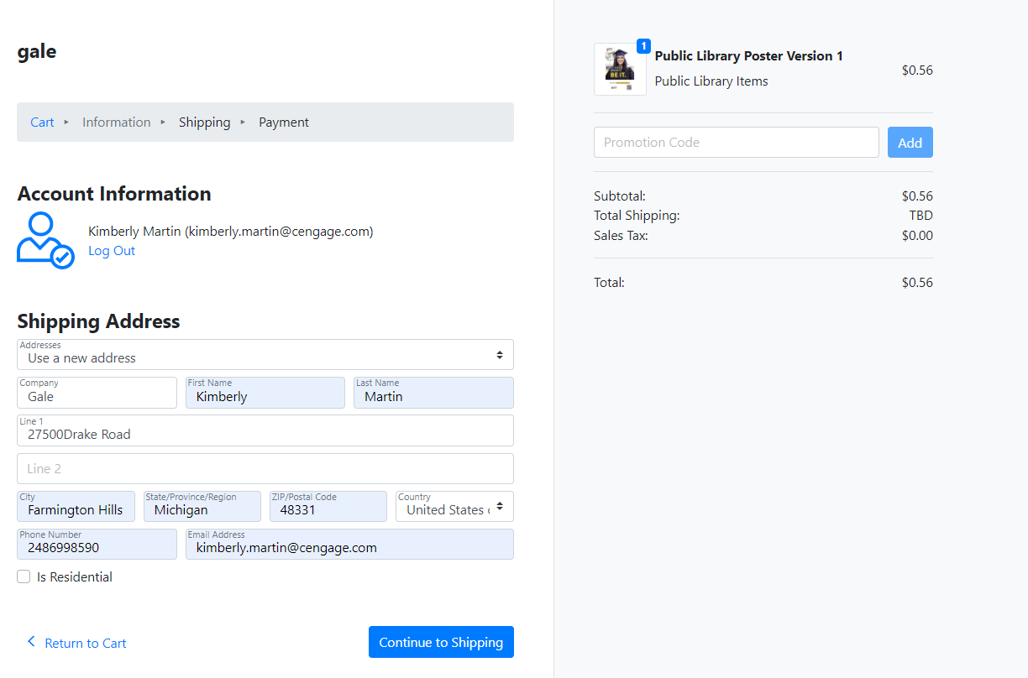
15. Then click the “Purchase” button.
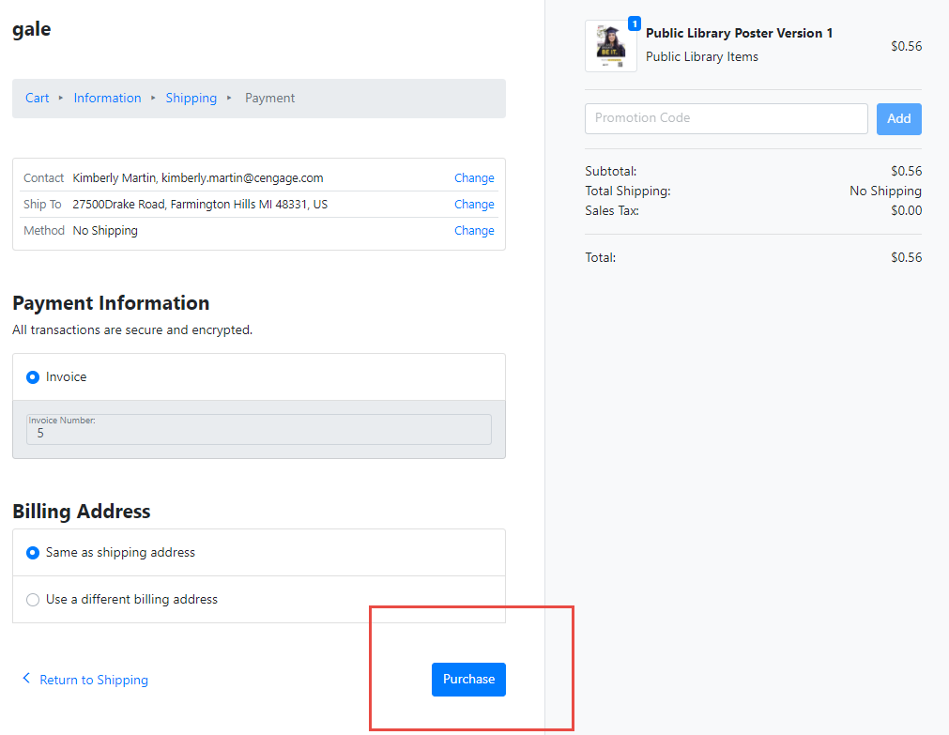
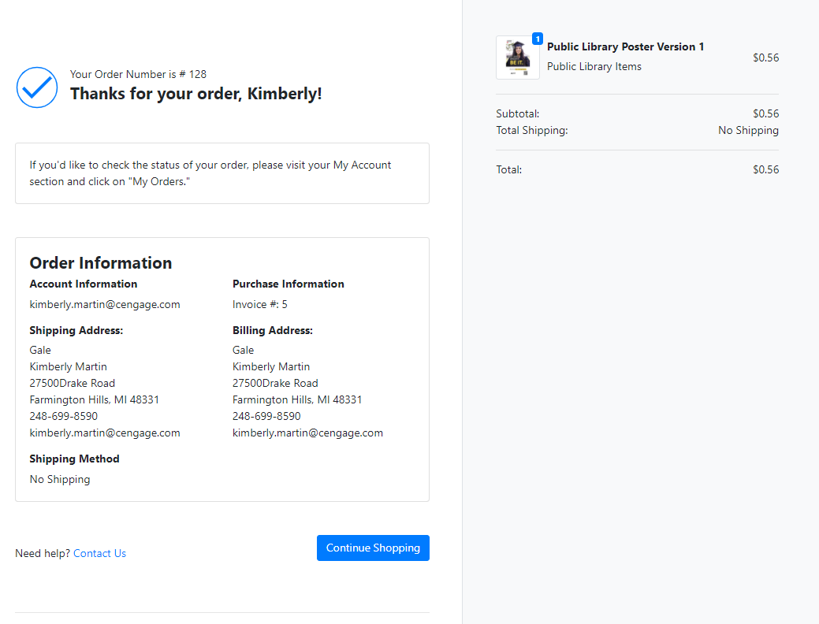

After your order is purchased, you will receive a confirmation email. Orders are processed and shipped once per week.
If you have any questions about ordering materials please contact Diana Doetzel at diana.doetzel@cengage or Kimberly Martin at kimberly.martin@cengage.com

